**Chapter 5 - Quiz**

1. Which statement is true about the **debug ip rip** command?
2. It searches through the running configuration and shows possible errors in the RIP configuration.
3. It displays RIP routing updates as they are sent and received.
4. It automatically identifies routing loops.
5. It shows the history of RIP updates over the previous 90 seconds.
6. What problem does the **passive-interface** command help resolve?
7. prevents confusion if both RIP v1 and RIP v2 are being advertised on a network
8. prevents wasted bandwidth and processing from unnecessary updates
9. prevents routing loops
10. prevents updates from being sent out without a password
11. What makes a router a boundary router in RIP?
12. if it is on the edge of an autonomous system
13. if a router has multiple interfaces in more than one major classful network
14. if it runs both RIP and EIGRP at the same time
15. if it is configured to be a boundary router by an administrator
16. What command is used with RIP to propagate default routes to neighbors?
17. network 0.0.0.0
18. ip summary-address rip address mask
19. ip default-network address
20. default-information originate
21. What command will create a candidate default route on a RIP router?
22. default-information originate
23. ip default-network 0.0.0.0
24. ip default-gateway 192.168.0.1
25. ip route 0.0.0.0 0.0.0.0 serial0/0/0
26. Refer to the following topology description to answer the question.

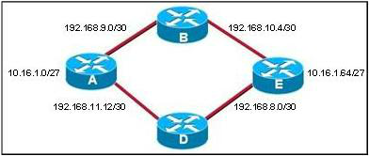

All routers are running RIP v1. The interfaces on all routers are up and stable. Users on the 10.16.1.0 network cannot access services on the 10.16.1.64 network. What is the cause of this problem?

1. The RIP hold-down timer in Router A is not allowing the 10.16.1.64 network into routing updates.
2. The network uses variable length subnet masking, and RIP v1 does not allow for this.
3. The 10.16.0.x subnets are discontiguous with each other.
4. Routers A and B need to have their interface configured as passive interfaces.
5. How does a router running RIP v1 determine the subnet mask of the routes that are received in routing updates?
6. The subnet mask is included in the routing update.
7. The router sends a request for the subnet mask to the sending router.
8. The router uses the subnet mask of the local interface of the default subnet mask for the address class in the routing update.
9. The router calculates the subnet mask based on the variable length subnetting in its own configuration.
10. The router defaults to 255.255.255.0 for all updates.
11. Refer to the following routing table output. What is the administrative distance of the route to the 192.168.5.0 network?

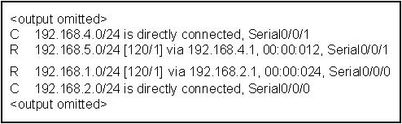

1. 0
2. 1
3. 12
4. 24
5. 120
6. What is the purpose of the **network** command when RIP is being configured as the routing protocol?
7. It identifies the networks connected to the neighboring router.
8. It restrict networks from being used for static routes.
9. It identifies the destination networks that the router is allowed to install in its routing table.
10. It identifies the directly connected networks that will be included in the RIP routing updates.
11. To ensure proper routing in a network, the network administrator should always check the router configuration to verify that appropriate routes are available. The commands listed will allow the network administrator to view the router configuration for the information needed.

Match each command to its result.

|  |  |  |
| --- | --- | --- |
| 1. show running-config | ⬄ | 1. Displays current configuration information for configured routing protocols and interfaces. |
| 1. show interfaces | ⬄ | 1. Checks to see that the interfaces are up and operational. |
| 1. debug ip rip | ⬄ | 1. Displays the network advertised in the updates as the updates are sent and received. |
| 1. show ip protocols | ⬄ | 1. Verifies that the routing protocol is running and advertising the correct networks. |
| 1. show ip route | ⬄ | 1. Verifies that routes received are installed in the routing table. |